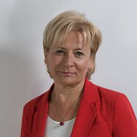

Dr Elzbieta Mikos-Skuza is a senior lecturer at the Faculty of Law, University of Warsaw, Poland and a visiting professor at the College of Europe in Natolin. Her fields of specialization include public international law, particularly international humanitarian law and peaceful resolution of disputes. She is the Director of Master Studies on Humanitarian Action (the so-called NOHA studies) and Postgraduate Studies on Humanitarian Assistance. For many years she has been volunteering with the Polish Red Cross, including the function of PRC’s vice-president. She is also the first vice-president of the International Humanitarian Fact-Finding Commission established under Protocol Additional I of 1977 to the Geneva Conventions of 1949.

