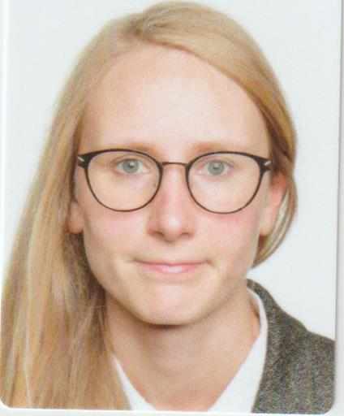

Pauline Lesaffre, Ph.D., is a FNRS Postdoctoral Researcher (Belgian National Fund for Scientific Research) at the University of Louvain. Prior to her FNRS mandate, she worked as a BAEF Postdoctoral Research Fellow (Belgian American Educational Foundation) at the U.S. Naval War College (Stockton Center for International Law) and at Yale Law School (Paul Tsai China Center). She previously was a Visiting Researcher at the Geneva Academy of International Humanitarian Law (IHL) and Human Rights and will soon undertake a research stay at the Max Planck Institute for Comparative Public Law and International Law (Heidelberg, DE) as a Humboldt Postdoctoral Research Fellow. Dr. Lesaffre’s work has been (or will be) published in International Law Studies, Boston University International Law Journal, The Military Law and the Law of War Review, Articles of War (blog), as well as in other journals, monographies and collective volumes. Dr. Lesaffre defended her Ph.D. thesis – on the challenges of cross-border armed conflicts for IHL – at the University of Louvain and holds two Master’s Degrees: a Master’s Degree in Civil and Criminal Law from the same University of Louvain and a Master’s Degree in Human Rights and International Humanitarian Law from the University of Paris II Panthéon-Assas.

